Blender Documentation

Joseph Trussell

Always make sure you have a segment down the middle, it helps to cut the model in half to create symmetry

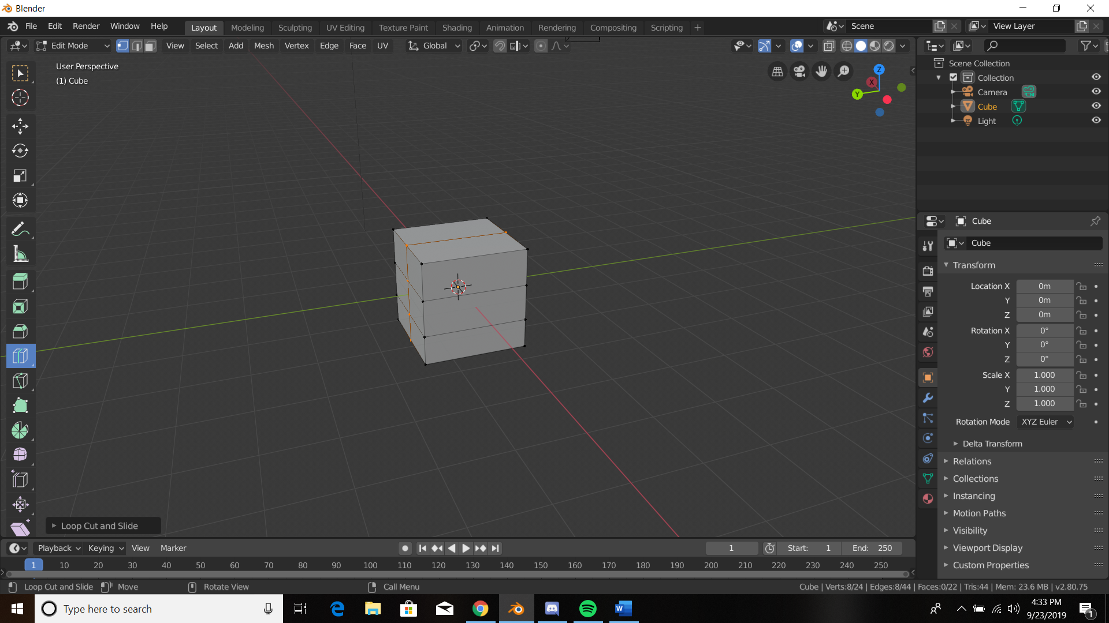

Try to remove faces that will not be seen on the model

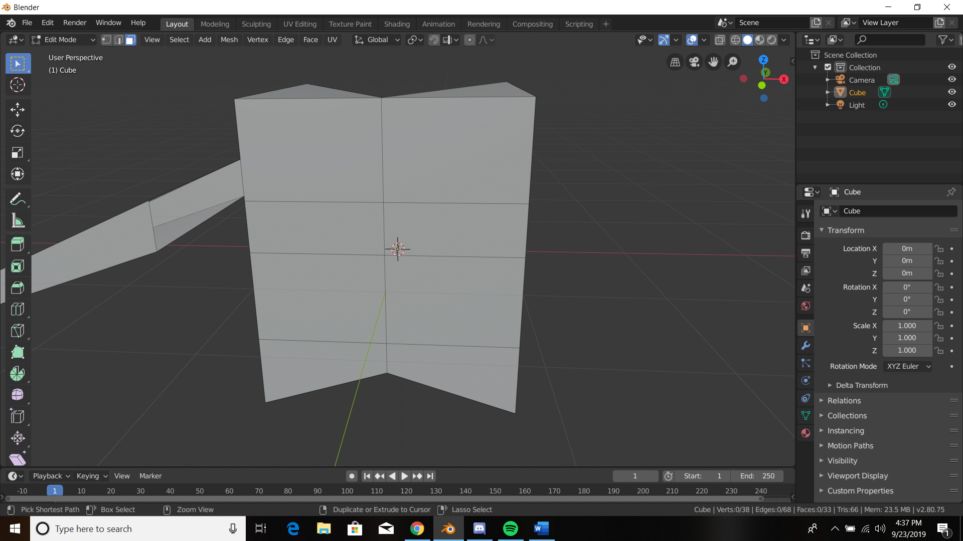

Easier to select while in wire frame mode, while selecting faces (as opposed to vertices, edges)

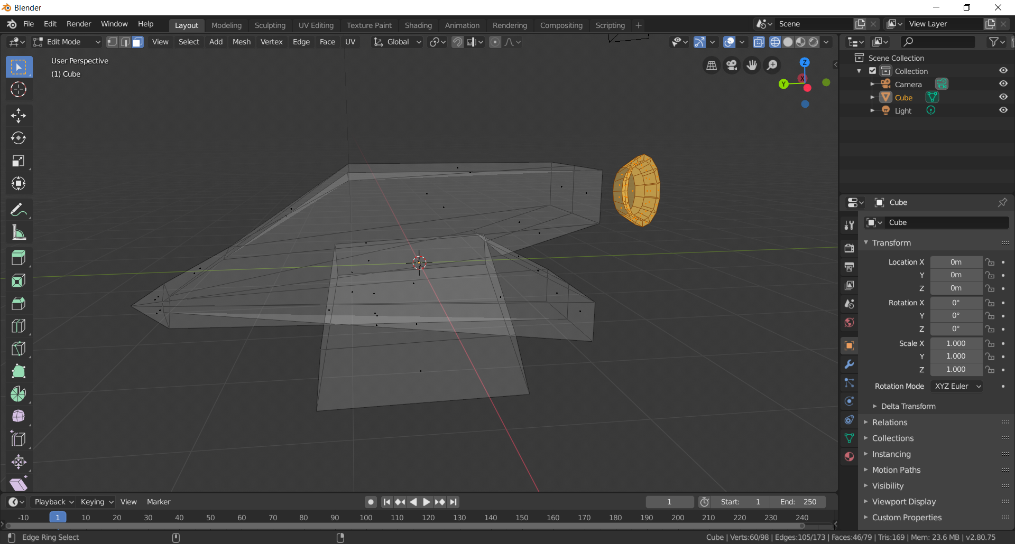

Cut models in half to have symmetry only after you have added everything you want to one half

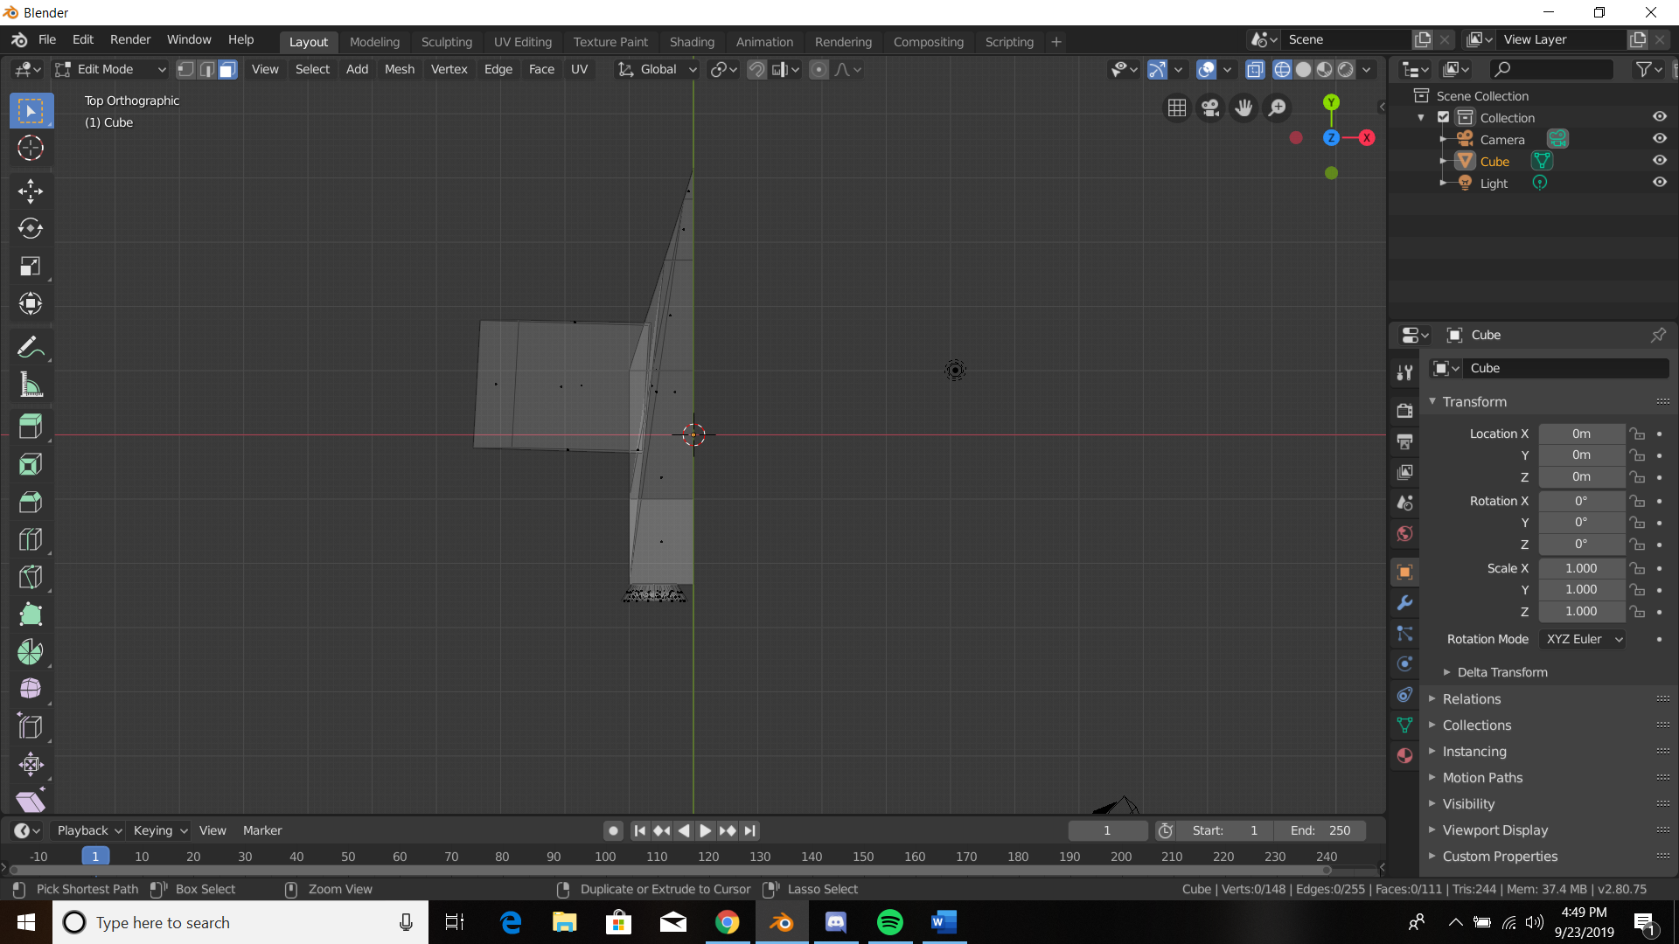

Ounce cut select the faces you want to mirror then Shift D to duplicate, right click return to original position and then Ctrl m to mirror and select vertices to mirror on (x, y, or z keys)

Line seam as best as you can by moving it only on one axis

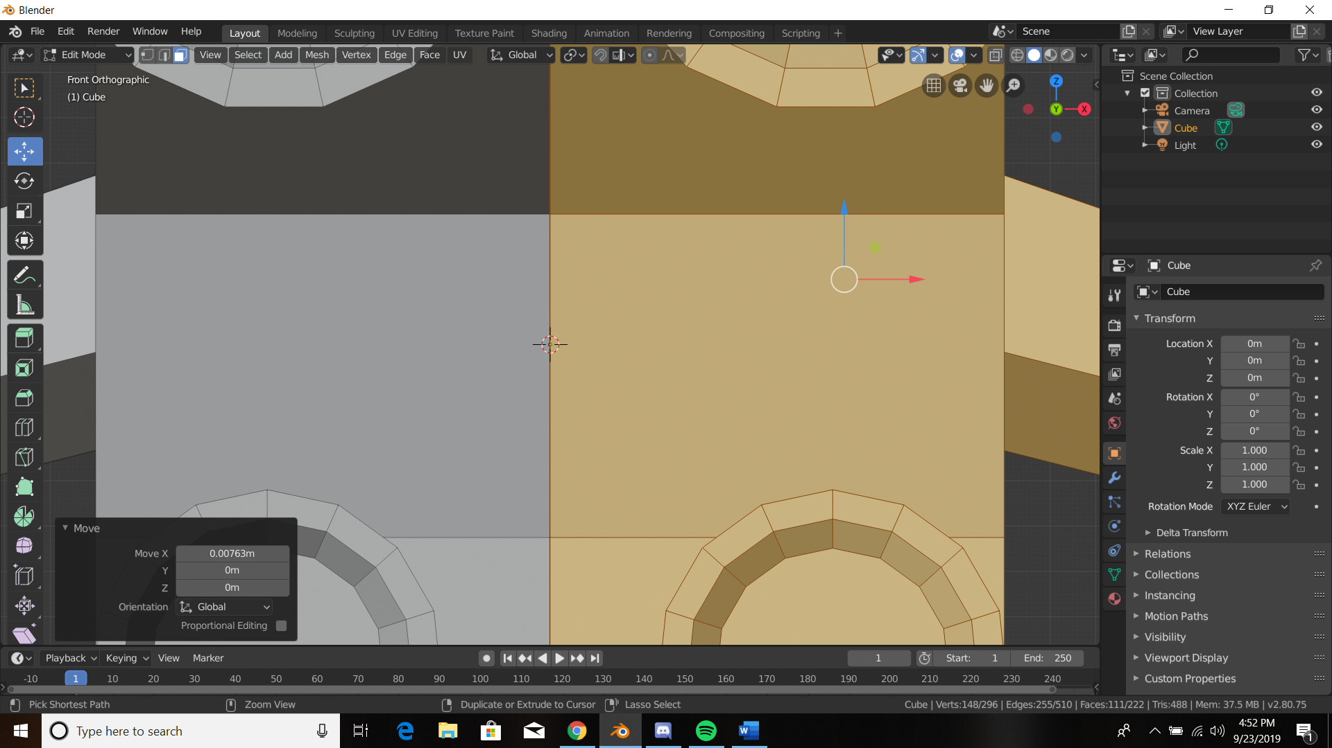

After checking seems make sure normal are the right way otherwise your model will collapse in on itself in unity or other game engines, Blue is a correct normal red is pointing inward

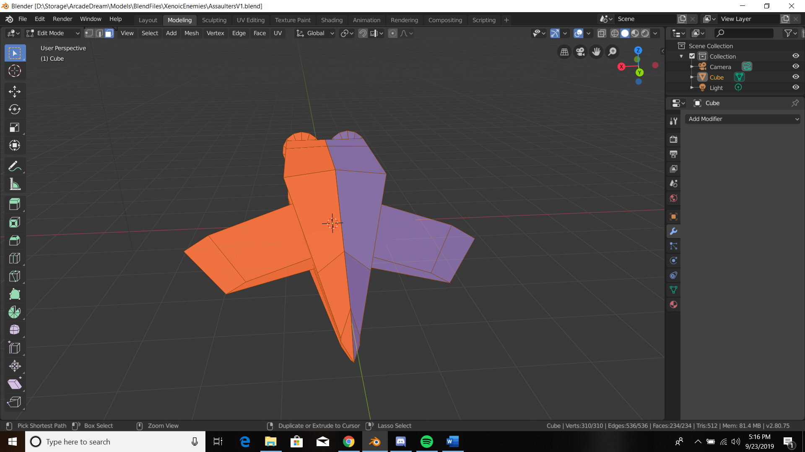

To fix select the red faces, go to mesh, normals, recalculate outside

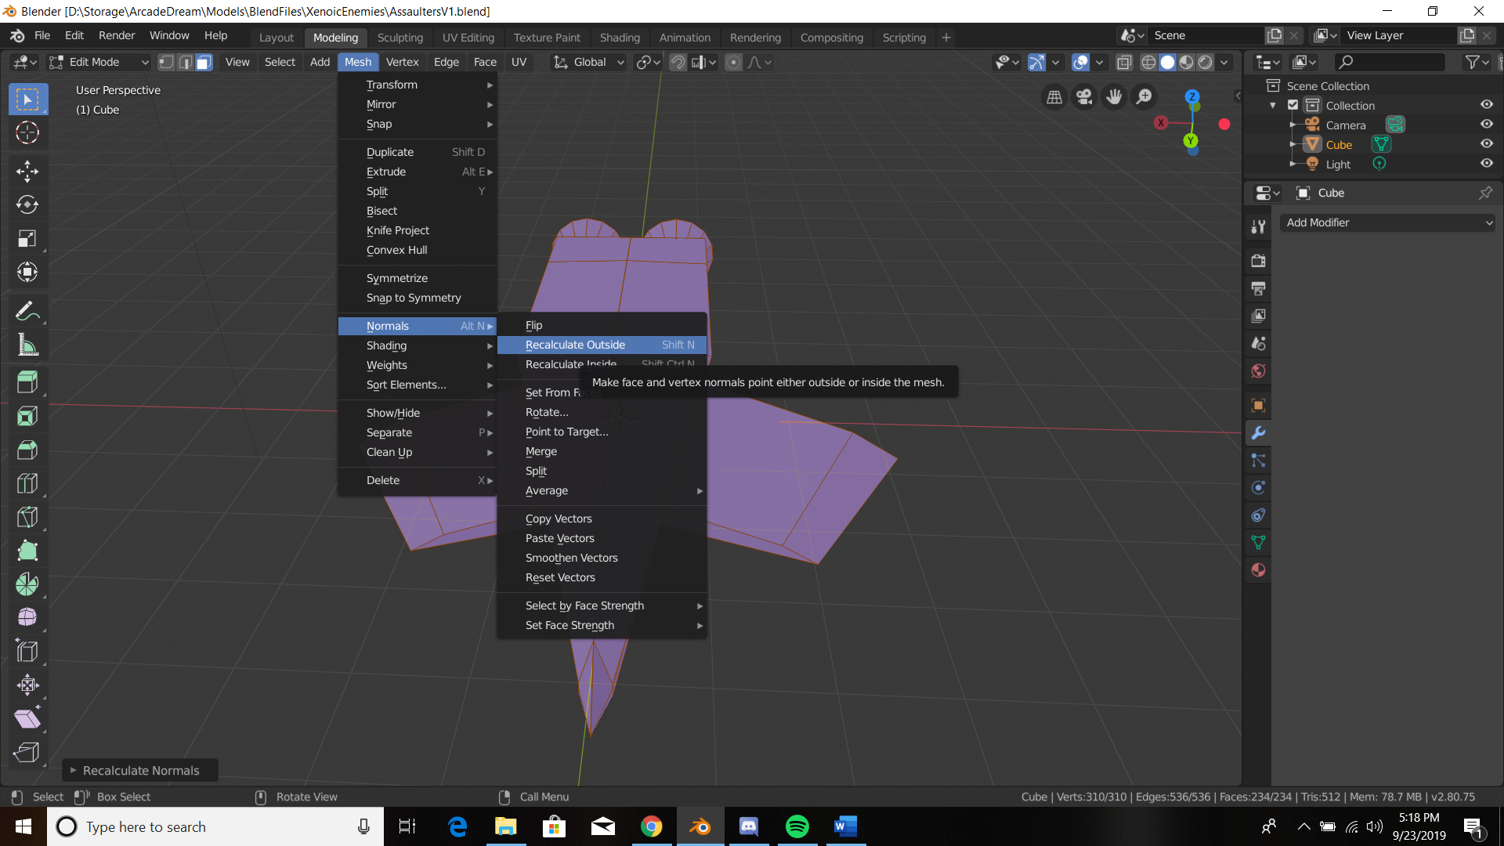

In edit mode press u to bring up the uv menu, select smart uv project

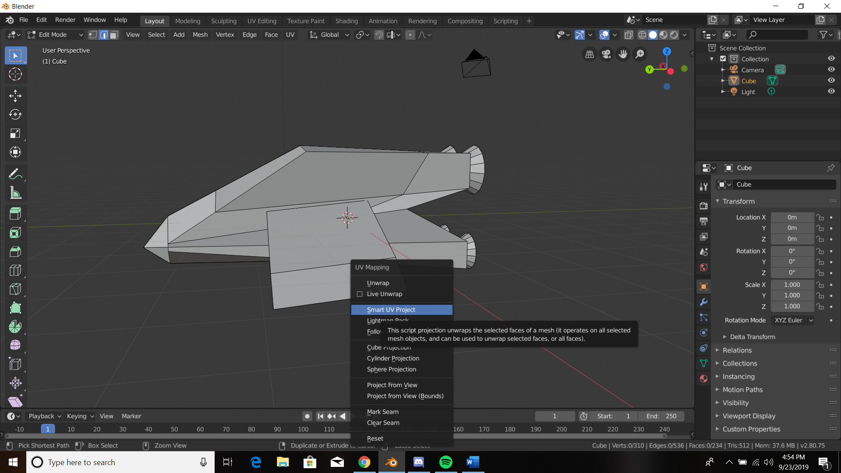

Island margins help create space for uv map so that not much changing need be done, but always make the minimum 3

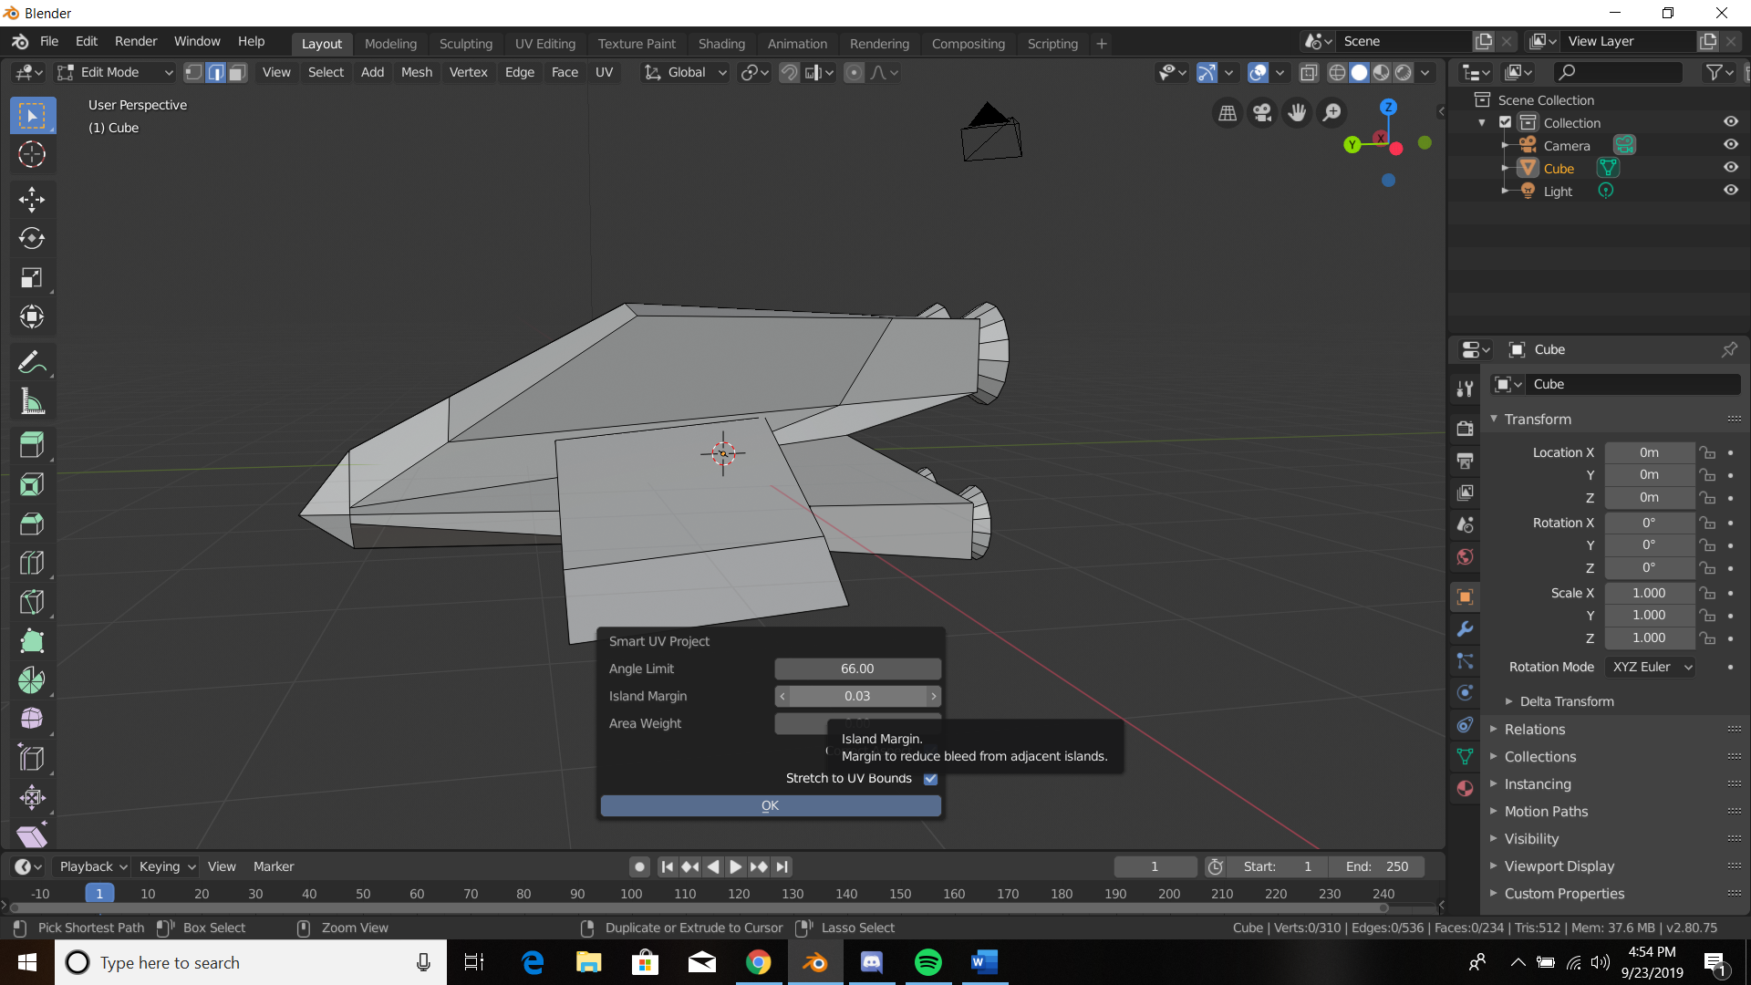

If the UV map does overlap go into uv editing and select which faces you wish to keep together on the right/edit screen

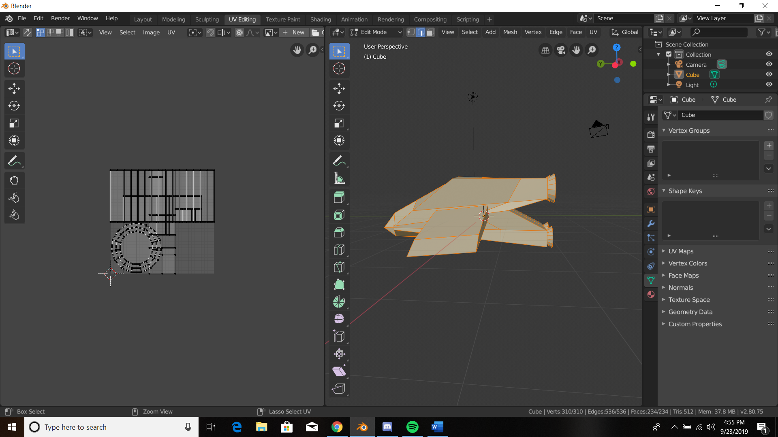

If you wish for your model to be colored symmetrically across both sides it is wise to keep those faces overlapped to save space.

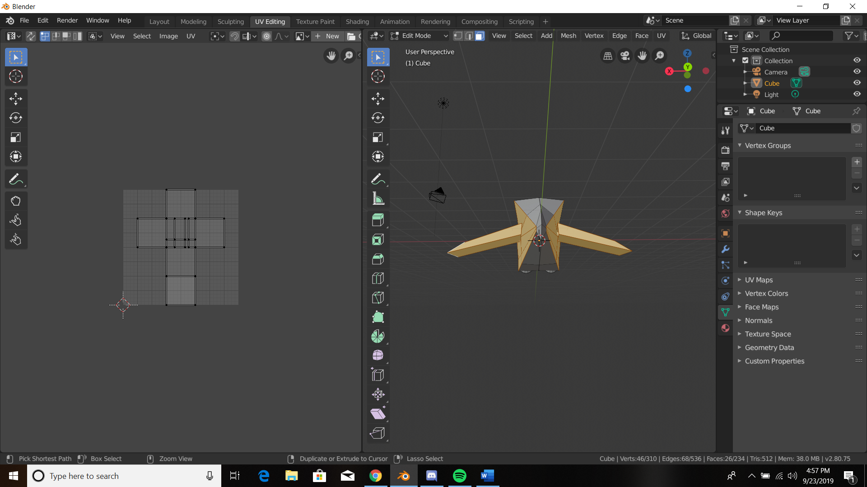

On the left screen you can then select, translate, scale and rotate however you see fit, if they are not in the grid though they will not be saved in an image, I place them out of bounds so I can re – arrange them later

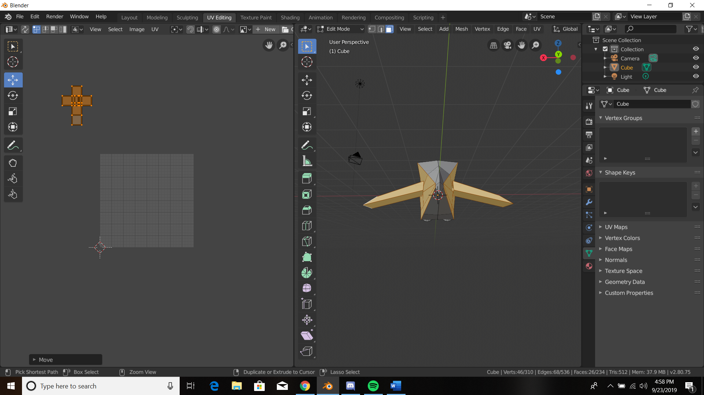

End product uv map, remember if your model has multiple objects each will have their own uv map

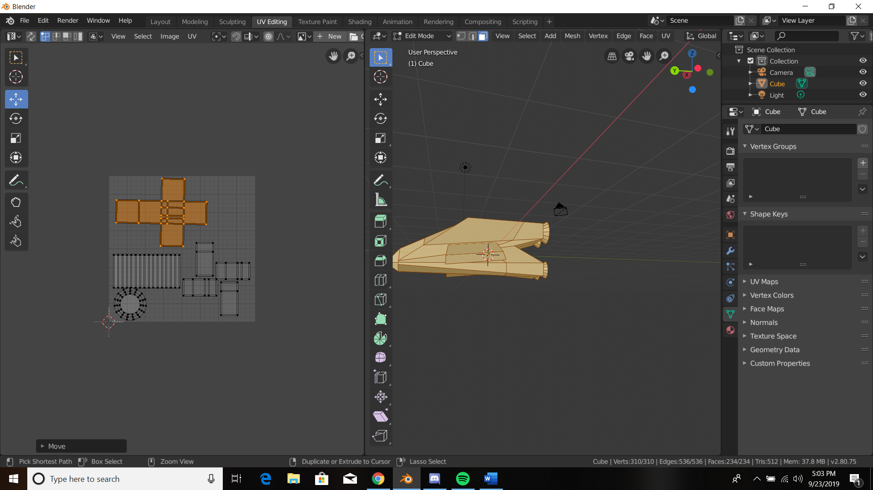

When texture painting make sure to keep the pixel count in increments of 1024, its also beneficial to pick lighter colors for base colors

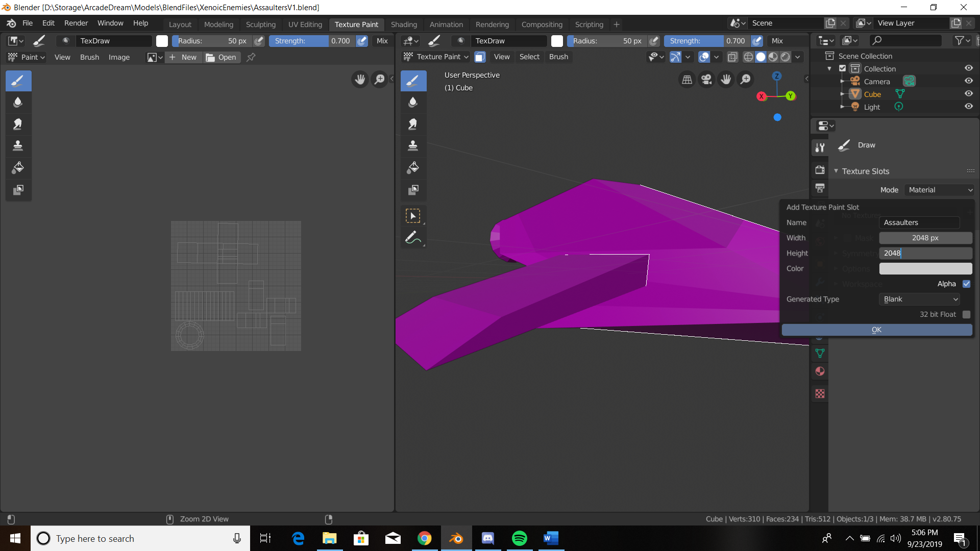

When painting using the paint only to face option can save a lot of time

